Eventi
Use Case Specification

Submitted to:

Asst. Prof. Ma. Rowena C. Solamo
Faculty Member
Department of Computer Science
College of Engineering
University of the Philippines, Diliman

Submitted by:
Dimaano, Aaron Diego I.
Lopez, Matthew S.
Torres, Jacob Angelo V.

In partial fulfillment of academic requirements
for the course
CS 191 Software Engineering I
of the
1st Semester, AY 2015-2016
Unique Reference:
The documents are stored in https://github.com/Tom-2013-06417/CS191-192_Event_Sharing/tree/master/02-Requirements%20Engineering.
Link to this document: https://github.com/Tom-2013-06417/CS191-192_Event_Sharing/blob/master/02-Requirements%20Engineering/1.0%20-%20View%20home%20page.pdf.

Document Purpose:
The purpose of this document is to exhaust the step-by-step process of the Use Cases in every scenario possible.

Target Audience:
To our project client and adviser, our fellow 191 classmates, and our future selves when they need to refer back to this document.

Revision Control:

Revision Date | Person Responsible | Version  Number | Modification
09/18/15 | Dimaano, Diego | 1.0 | Initial Document
09/25/15 | Torres, Jacob | 1.1 | Edited the post-conditions

Use-Case Name: View home page

Description: This is the first page a user sees after loading the Eventi website. Displayed in the home page are the different events ranging in various tiles depending on popularity. Everyone is a Guest User unless they register and log in the site.

Preconditions: There is an internet connection to the Eventi server and a device with browsing capabilities.

Flow of Events:

Scenario Name | Description
Scenario 1 (Basic Flow)  User visits the website | - User accesses the website through the browser  - User sees the home page
Scenario 2  Site is down | - User tries to access the website through the browser  - User receives an error message from the site
Scenario 3  Connectivity or mobile app hardware problem | - User accesses the website through the browser  - User receives an error message from the site indicating that there was a problem regarding the machin

Activity Diagram of the Flow of Events:

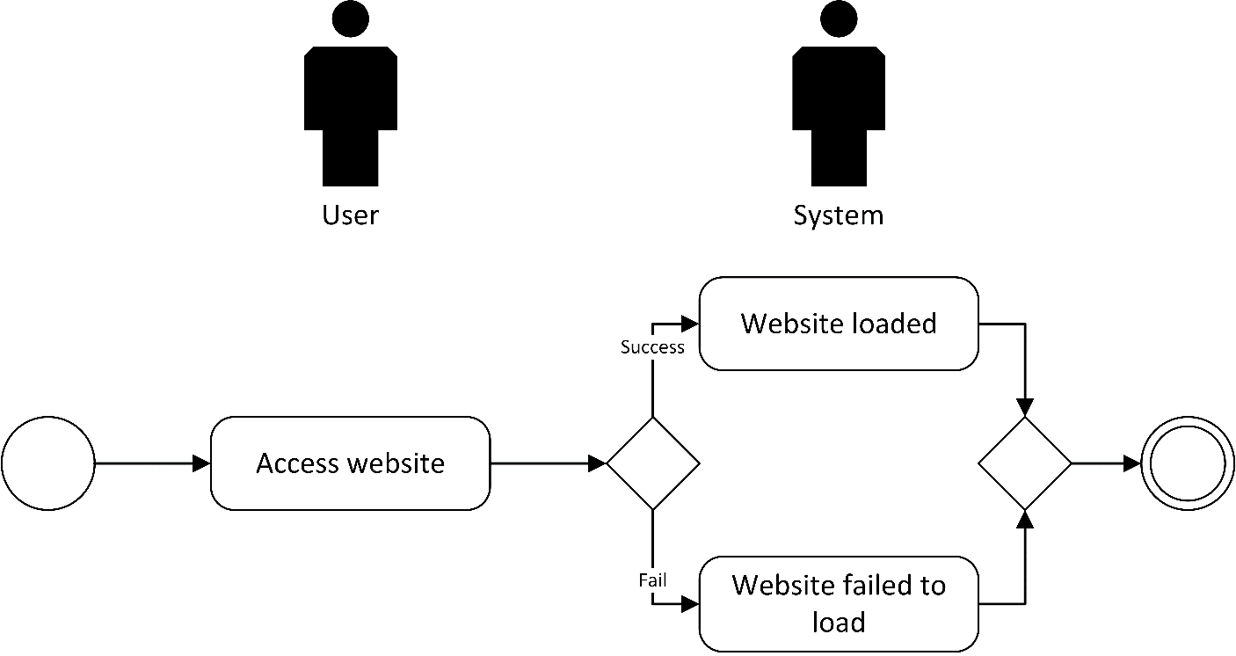

Post-conditions: NONE

Special Requirements: NONE

